Exp. No: 10
PHOTODIODE RESPONSE AND SENSITIVITY ANALYSIS USING OPTISYSTEM
OBJECTIVES
1. Design and simulate an optical receiver using PIN and APD photodetectors in OptiSystem.
2. Observe the photocurrent generated for a given received optical power and determine the responsivity of the detectors.
3. Determine the receiver sensitivity (minimum received power), bandwidth and the variation of SNR and BER with received power.
4. Compare the PIN and APD receivers and evaluate photodetector performance.
SOFTWARE REQUIRED
• OptiSystem software
CIRCUIT DIAGRAM
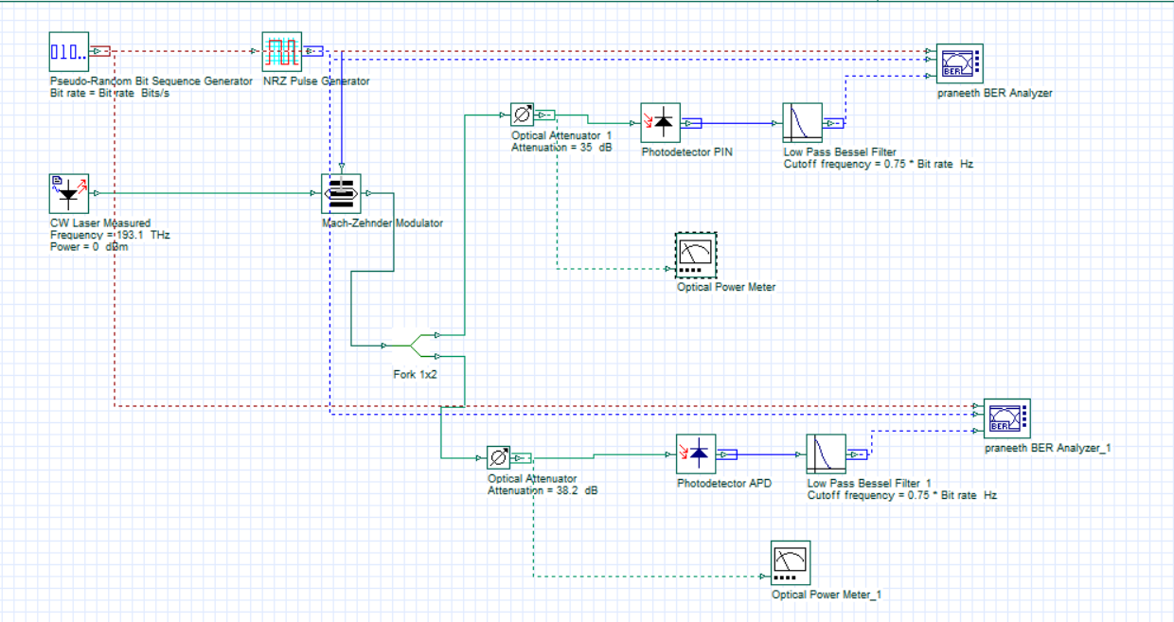
OUTPUTS
- Optical Power Meter Readings
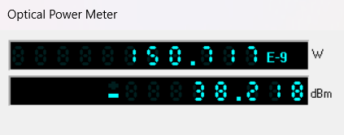
PIN Branch

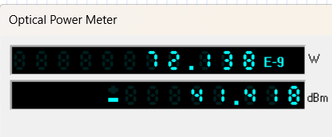
APD Branch

- BER Analyzer Readings & Eye Diagrams
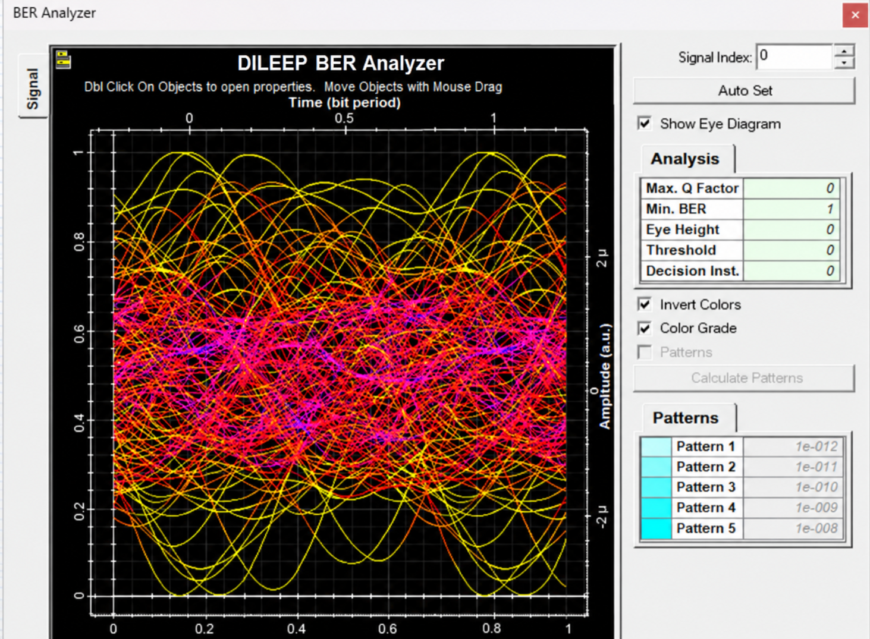
PIN Receiver

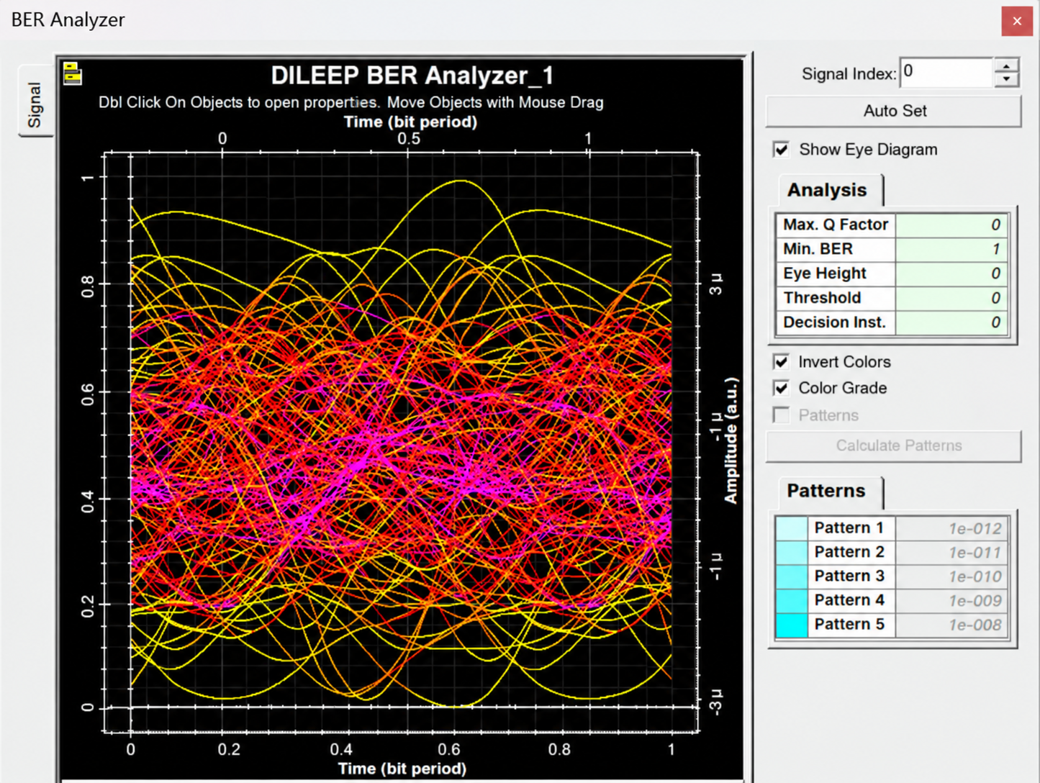
APD Receiver
Reflection
This experiment demonstrates the engineering trade-off between detector simplicity and detection sensitivity: while PIN diodes provide stable, linear, low-noise detection, APDs significantly improve weak-signal reception through internal carrier multiplication.

LABORATORY PERFORMANCE ASSESSMENT RUBRIC
Objective | Assessment Criterion | Excellent – 4 | Good – 3 | Satisfactory – 2 | Needs Improve-ment – 1 | Weight-age
Design the OptiSystem PIN/APD  receiver circuit with correct components and parameters. | Circuit Setup and Parameter Definition | Builds the complete circuit (laser, modulator, Fork 1×2, attenuators, PIN/APD, filters, power meters, BER analyzers) with all parameters correct (193.1  THz, 0 dBm, 35/38.2 dB, 0.75 ×  bit rate), independently. | Builds the circuit with minor connection or parameter errors and limited assistance. | Builds only part of the circuit or needs considerable assistance; has unit/parameter errors (e.g., dB vs dBm). | Unable to build the circuit or set the parameters. | 25
Run the simulation and record received power, Q factor and BER for both receivers. | Simulation Execution and Data Acquisition | Runs the simulation and records received power (W and dBm), eye diagram, Q factor, BER and the attenuation sweep correctly for PIN and APD. | Records all quantities with minor errors or omissions. | Records some quantities with noticeable errors or inconsistencies. | Unable to run the simulation or record the values. | 25
Obtain eye diagrams and BER/SNR  plots; determine responsivity, sensitivity and bandwidth. | Graph Plotting and Sensitivity Determination | Plots accurate eye diagrams and BER (semi-log) / SNR curves with labelled axes and a BER = 10⁻⁹ line; sensitivity within  ±1 dB,  responsivity and bandwidth within 10% of the reference. | Plots the curves with minor errors; sensitivity, responsivity and bandwidth identified with small deviation. | Plots partial or poorly scaled curves; sensitivity, responsivity or bandwidth approximate. | Unable to plot the curves or determine the parameters. | 25
Interpret photocurrent–power relation, SNR/BER  variation and PIN vs APD  performance. | Analysis and Engineering Interpretation | Correctly explains linear photocurrent, noise-limited regions, SNR/BER trend and the APD gain advantage, and links results to detector selection. | Explains the trends with minor errors and reasonable interpretation. | Performs basic interpretation with noticeable errors . | Unable to interpret the results. | 25

RESULT
Thus, the response and sensitivity of the PIN and APD photodetectors were successfully simulated and analyzed using OptiSystem.

